NOME...........................................COGNOME................................................CLASSE …… DATA……….

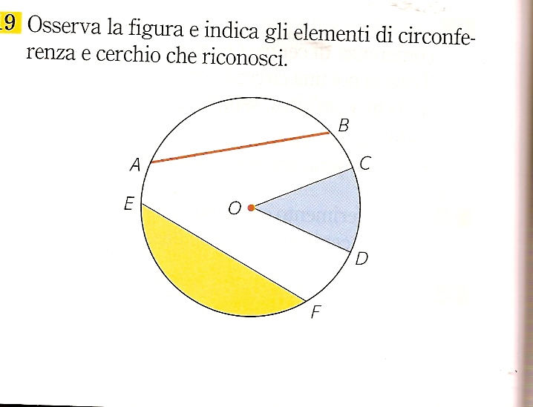
_____________________
_____________________
_____
________________________________
_____
________________________
_____
________________________________________________
_____
_________________________________

SCEGLI I TERMINI CORRETTI E COMPLETA LA FIGURA

SEGMENTO CIRCOLARE – ARCO – SETTORE CIRCOLARE – CERCHIO – CORDA – CENTRO – CORONA CIRCOLARE – RAGGIO – DIAMETRO – SEMICERCHIO

